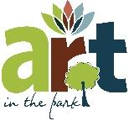
Art in the Park 2023
Artist / Vendor Application

Date:______________________
Name:__________________________________________________________________Phone:________________________________________
Address:______________________________________________________City/State/Zip:_______________________________________
E-mail: (all notifications will be sent via email when possible): ________________________________________________
List artwork medium: (i.e. oil, acrylic, mixed media, clay, fiber, metal, etc.) ____________________________________
_________________________________________________________________________________________________________________________Approx. # of pieces you wish to display and size of works: ______________________________________________________

PLEASE NOTE: ALL APPLICATIONS FOR THE ART IN THE PARK ARE DUE BY May 31.
- Individual Artists fee is $15 if paid by May 12th, $20 after. Last day to register is May 31. Check with us for availability after this date. PLEASE MAKE CHECKS PAYABLE TO: Iredell Arts Council. Address is below. Payment can be made online as well at : Venmo, Iredell Arts Council @IredellArts Council
Application information can be sent via email to mail@iredellartscouncil.org.
2. All artists must submit three images of your work for consideration. Submissions may be by e-mail (mail@iredellartscouncil.org) or mail to 203 S. Meeting, Statesville, NC 28687. If you want your material returned, please include a self-addressed stamped envelope to fit your juried material. If you have participated before and will show similar work, then you are exempt from sending images.
3. All work displayed at Art in the Park must be original fine art/craft created by the applicant.
4. All materials used to create jewelry must reflect most handcrafted components. For three-dimensional works such as jewelers and sculptors, silver-smithing, weaving and sculptural manipulation of materials is preferred. There will be no resale of crafts or art, all work must be created by the artist/artisan.
5. All individual artists will be juried and contacted regarding acceptance. If not chosen, the fee will be returned.
6. You will be notified of your acceptance as soon as possible. Upon notification you will be assigned a vending location.
7. Display space may vary by location and artists are responsible for all items required to display artwork. Set-up time will be between 12:00pm and 2:00 pm. ART IN THE PARK begins at 2:00 pm and ends at 7:00 pm.
8. Artists are responsible for all sales and sales taxes. Please make sure you have money available to make change if you are selling artwork.
9. Once your work is juried and accepted, there will be no refunds unless the event is canceled by IAC. Weather will not be cause for cancellation of the event.
Mail Application and Fee to: Iredell Arts Council, 203 S. Meeting Street, Statesville, NC 28677
Questions? Please Call 704-873-6100
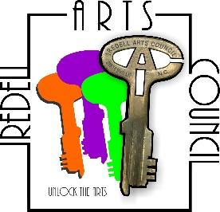
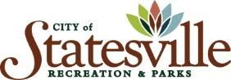
2023 Art in the Park, June 10th
2:00 pm until 7:00 pm
Martin Luther King Jr Park, Statesville, NC

